18/10/2026 NAME: Charulatha.V
Experiment :5 REG.NO.:192424031
SLOT: A
SEMESTER:MS2 September 2026
COURSE CODE:CSA4701
COURSE NAME:Deep Learning

Bias–Variance, Overfitting and Underfitting Analysis
Scenario:
A student-performance prediction model uses a linear regression algorithm on nonlinear data. Compare training and testing errors to identify whether the model is underfitting.
Algorithm:
- Start the program.
- Import NumPy, Matplotlib, and Scikit-learn libraries.
- Generate nonlinear student-performance data.
- Split the dataset into training and testing sets.
- Create a Linear Regression model.
- Train the model using the training data.
- Predict student performance for training and testing data.
- Calculate training and testing Mean Squared Error (MSE).
- Compare the errors to identify underfitting.
- Plot the actual data and predicted regression line.
- Display the results and stop.
Source code:
import numpy as np
import matplotlib.pyplot as plt
from sklearn.model_selection import train_test_split
from sklearn.linear_model import LinearRegression
from sklearn.metrics import mean_squared_error

# Generate nonlinear student-performance data
np.random.seed(42)
X = np.linspace(0, 10, 100).reshape(-1, 1)
y = 5 * X.ravel()**2 + 10 * X.ravel() + np.random.normal(0, 15, 100)

# Split data into training and testing sets
X_train, X_test, y_train, y_test = train_test_split(
X, y, test_size=0.2, random_state=42
)

# Create and train the linear regression model
model = LinearRegression()
model.fit(X_train, y_train)

# Make predictions
y_train_pred = model.predict(X_train)
y_test_pred = model.predict(X_test)

# Calculate errors
train_error = mean_squared_error(y_train, y_train_pred)
test_error = mean_squared_error(y_test, y_test_pred)

# Display results
print("Training MSE:", round(train_error, 2))
print("Testing MSE:", round(test_error, 2))

if train_error > 1000 and test_error > 1000:
print("Conclusion: The model is underfitting.")
elif test_error > train_error * 1.5:
print("Conclusion: Possible overfitting.")
else:
print("Conclusion: No strong overfitting detected.")

# Plot actual data and regression line
plt.figure(figsize=(8, 5))
plt.scatter(X, y, label="Actual Data")
plt.plot(X, model.predict(X), color="red",
label="Linear Regression")
plt.xlabel("Study Hours")
plt.ylabel("Student Performance Score")
plt.title("Underfitting Analysis using Linear Regression")
plt.legend()
plt.grid(True, alpha=0.3)
plt.show()

# Result
print("Result: Training and testing errors were compared.")
Output:
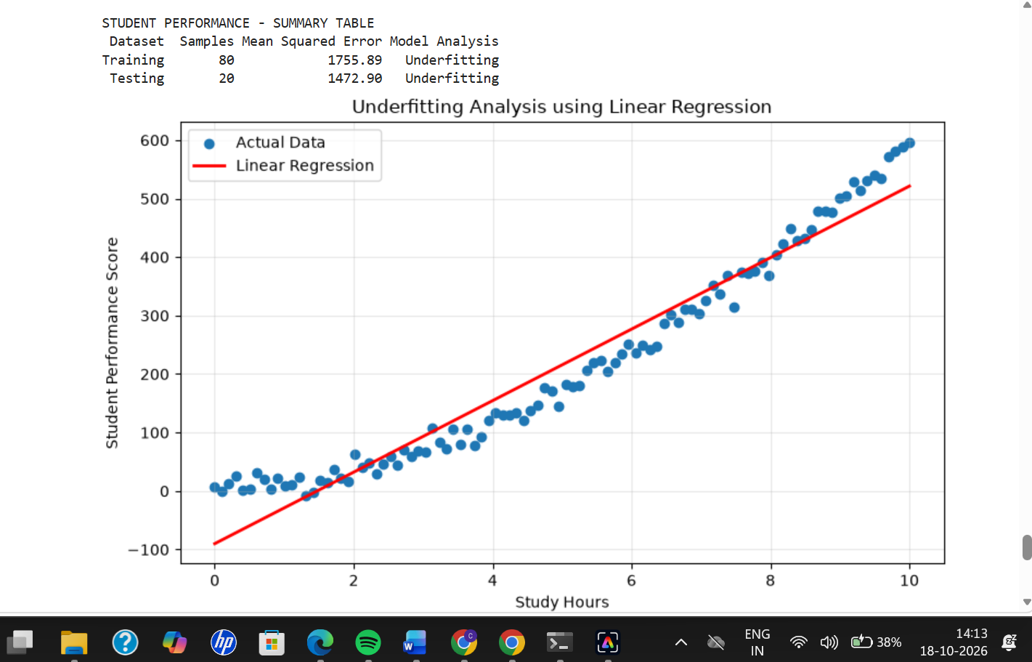

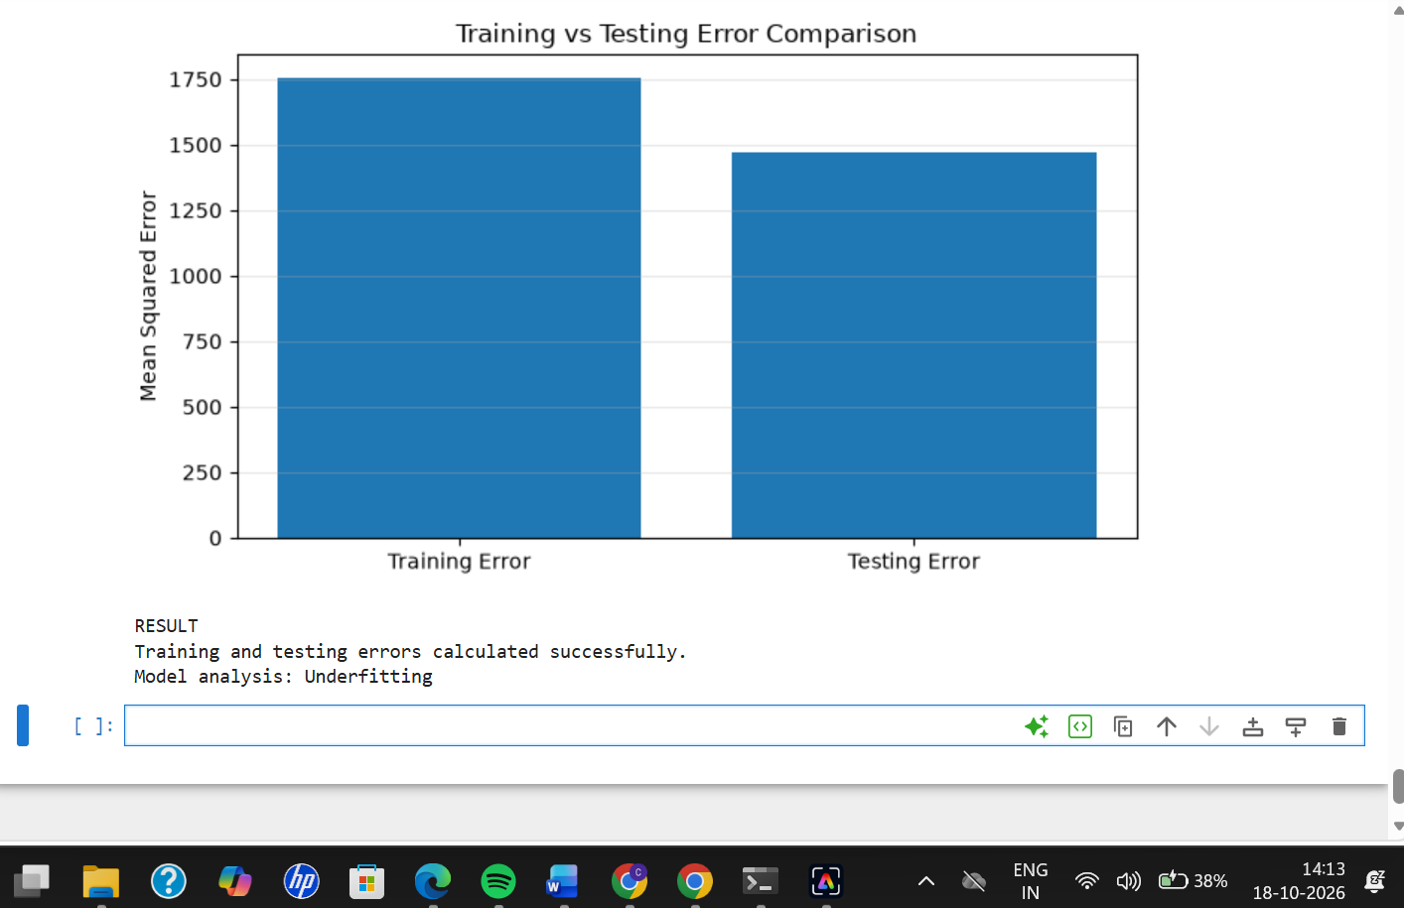
Result:
Thus, a Linear Regression model was trained on nonlinear student-performance data. Training and testing errors were calculated and compared. Since a linear model cannot adequately represent a quadratic relationship, it is expected to show high training and testing errors, indicating underfitting. The graph helps visualize the model's inability to capture the nonlinear pattern.

